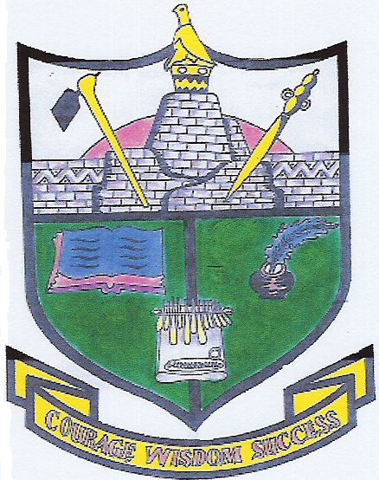

**Great Zimbabwe University**

School of Natural Sciences

**Department of Mathematics and Computer Science**

**Course Outline:**

**Subject Area: Mathematics**

**Course Name: Discrete Mathematics**

**Course Code: HCS 123**

**Campus: GZU**

**Semester 1, 2021**

**Contact Details for Instructors:**

|  |  |
| --- | --- |
| **Lecturer: Mrs. M. Mandiudza**  **Location: GZU Main Campus**  **Phone: 0715 119731**  **Email: mmandiudza@gzu.ac.zw**  **Office Hours: 8:00am-4:30pm** | **Lecturer:**  **Location:**  **Phone:**  **Email:**  **Office Hours:** |

## Syllabus

**1. Vectors**

Vectors and Scalars, Basic Definitions, Unit Vectors, Magnitude of a Vector, Vector Equation of a Straight line, Inner Product, Vector Equation of a Plane.

**2. Sets And Relations**.

Introducing sets; set description (element list and set-builder forms); the Russell paradox;

set axioms (simplified versions from Axiom of Extensionality to the Powerset Axiom);

set operations; set products via ordered pairs; relations, arrow diagrams for relations,

relation types (reflexive, symmetric, anti-symmetric, transitive, equivalence); equivalence relations, equivalence classes and partitions; revisiting functions as special relations.

**3. Matrices**

Addition, Subtraction and Multiplication of Matrices, Triangular and diagonal Matrices, Transpose of a Matrix, Symmetric Matrices, The Trace of a Matrix, Determinants and Inverses of Matrices.

**4. Linear Equations**

Row Echelon Form, Homogeneous Equations and their Solutions.

5. Differential Equations

Separable Differential Equations, Exact Equations, Homogeneous Differential Equations, Bernoulli’s Equation, Reduction of Order, Non-Homogeneous Linear Differential Equations.

References:

1. **Anton H. Elementary Linear Algebra, John Wiley and Sons, 1973.**
2. **Cox W. Ordinary Differential Equations, Modular Mathematics Series, Arnold 1995.**
3. **Wilde C. Linear Algebra, Addison- Wesley 1987.**

**Assessment**

|  |  |
| --- | --- |
| Assessment | Course work mark |
| Two assignments and two tests | 25% |
| Final examination 3 hour paper | 75% |